Lesson 0

Skills Tested

* Design and implement data storage (40–45%)
* Design and develop data processing (25–30%)
* Design and implement data security (10–15%)
* Monitor and optimize data storage and data processing (10–15%)

Study Program for DP-203

<https://www.linkedin.com/pulse/how-prepare-azure-dp-203-exam-week-munish-malhotra/?trk=public_post-content_share-article>

Lesson 1

Azure data store services

<https://www.youtube.com/watch?v=H-3lAESh-9A>

Azure Data Lake Storage Gen2

Azure **B**lobs

 Azure **F**iles

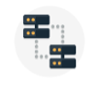 Azure **Q**ueues

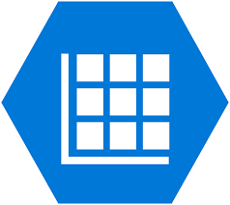 Azure **T**ables



**Non-Relational DB management systems**

Azure Data Lake Storage Gen2

*(Azure Storage Account)*

Azure **B**lobs

 Azure Cosmos DB

**Relational DB management systems**

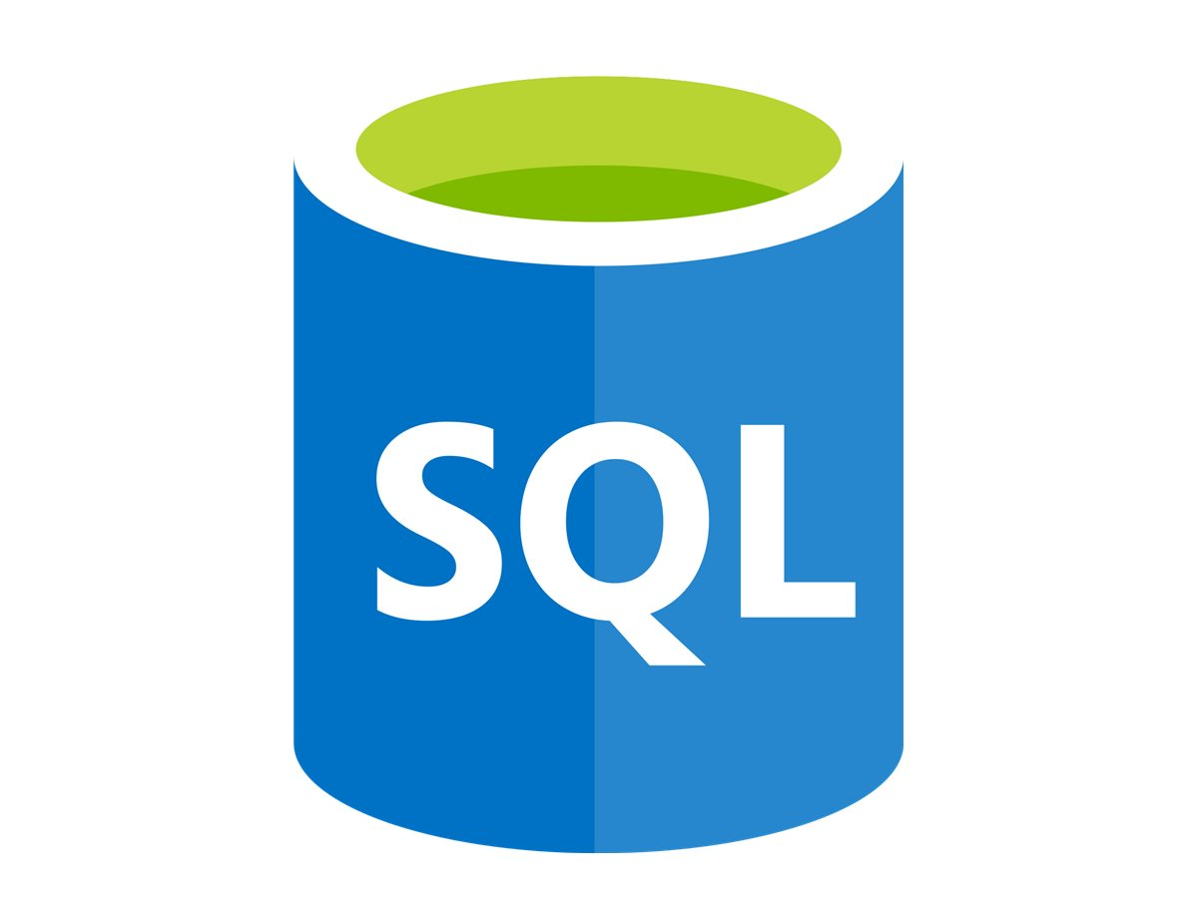 Azure SQL Database

Azure Database for PostgreSQL



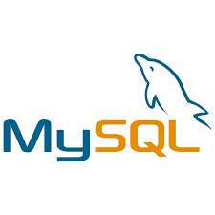 Azure Database for MySQL

- Azure Database for MariaDB

**Data Analytics**

(NoSQL)

 Azure Synapse Analytics

Azure Data Lake Storage Gen2



*(Azure Storage Account)*

**Key/Value stores**

*(NoSQL)*

- Azure Cosmos DB Table API

- Azure Cache for Redis

- Azure Table Storage

*(Azure Storage Account)*

**Object Storage**

- Azure Cosmos Blob Storage

- Azure Data Lake Storage Gen2

*(Azure Storage Account)*

Graph Databases

(NoSQL)

- Azure Cosmos DB Gremlin API

- SQL Server

[Azure] Four Storage options:

B-F-Q-T

|  |  |  |  |  |  |
| --- | --- | --- | --- | --- | --- |
| **Tool** | | **Ingest** | **Store** | **Prep & Train** | **Model & Serve** |
|  | **Azure Files** |  | ✓ |  |  |
|  | **Azure Queue** |  | ✓ |  |  |
|  | **Azure Data Lake Storage Gen 2**  (Non-relational data store) |  | ✓ |  |  |
|  | **CosmosDB**  (Non-relational data store) |  | ✓ |  | ✓ |
|  | **Azure Blob (WASB)**  (Non-relational data store) |  | ✓ |  |  |

**Azure Blob (WASB):** A scalable object store for text and binary data

This is a data store that will store but not query data, your cheapest option is to set up a storage account as a Blob store.

Blob storage works well with images and unstructured data

Flexible pricing options (cold vs hot storage)

**Azure Files:** Managed file shares for cloud or on-premises deployments. Accessible via the industry standard Server Message Block (SMB) protocol

**Azure Queue:** Azure Queue storage is a service for storing large numbers of messages that can be accessed from anywhere in the world.

Azure Table: A NoSQL store for no-schema storage of structured data

Azure Storage Tables is aimed at high capacity on a single region (optional secondary read only region but no failover), indexing by PK/RK and storage optimized pricing;

Azure Cosmos DB is a globally distributed database service.

**high throughput** (single-digit millisecond latency),

**global distribution** (multiple failover), SLA-backed predictive performance with automatic indexing of each attribute/property and a pricing model focused on throughput.

Data Lake Layers

Files (Compression Ratios)

CSV vs Parquet vs Avro.

<https://medium.com/ssense-tech/csv-vs-parquet-vs-avro-choosing-the-right-tool-for-the-right-job-79c9f56914a8>

**CSV**

- Bulk processing data

- Not always best choice for Spark

**Parquet**

- columnar storage is optimized for picking a section of columns.

- if you only need part of each record, the latency of reads is considerably lower.

**Avro**

*Good for unstructured /schema differentiating data*

- Schema is richer than Parquet’s

- allows us to evolve the schema by adding, removing, or modifying the columns of a record, with much greater ease than Parquet

|  |  |  |  |
| --- | --- | --- | --- |
|  | CSV | Parquet | Avro |
| Read or Write | Write | Read | Write |
| Row or Column |  | Column | Row |
| Most Compatible Platforms | ALL | Spark | Kafka, NiFi |
| Compression Ratio |  | 97.5% | 91.24% |
| Compression |  |  |  |
| Schema Evolution Support |  |  |  |

Azure Data Lake Storage Gen2

Lesson 2

Azure SQL Database

-- Create a new table.

CREATE TABLE { database_name.schema_name.table_name | schema_name.table_name | table_name }

(

{ column_name <data_type> [ <column_options> ] } [ ,...n ]

)

[ **WITH (** <table_option> **[ ,...n ] )** ]

[;]

<column_options> ::=

[ COLLATE Windows_collation_name ]

[ NULL | NOT NULL ] -- default is NULL

[ IDENTITY [ ( seed, increment ) ]

[ <column_constraint> ]

<column_constraint>::=

{

DEFAULT constant_expression

| PRIMARY KEY NONCLUSTERED NOT ENFORCED -- Applies to Azure Synapse Analytics only

| UNIQUE NOT ENFORCED -- Applies to Azure Synapse Analytics only

}

**<table_option> ::=**

{

**CLUSTERED COLUMNSTORE INDEX -- default for Azure Synapse Analytics**

**| CLUSTERED COLUMNSTORE INDEX ORDER (column [,...n])**

**| HEAP --default for Parallel Data Warehouse**

**| CLUSTERED INDEX ( { index_column_name [ ASC | DESC ] } [ ,...n ] )**

-- default is ASC

}

{

**DISTRIBUTION = HASH ( distribution_column_name )**

**| DISTRIBUTION = HASH ( [distribution_column_name [, ...n]] )**

**| DISTRIBUTION = ROUND_ROBIN** -- default for Azure Synapse Analytics

**| DISTRIBUTION = REPLICATE** -- default for Parallel Data Warehouse

}

**| PARTITION ( partition_column_name RANGE [ LEFT | RIGHT ]**

-- default is LEFT

FOR VALUES ( [ boundary_value [,...n] ] ) )

**1**

**2**

**3**

<https://www.cathrinewilhelmsen.net/table-partitioning-in-sql-server/#:~:text=Range%20left%20means%20that%20the,value%20in%20the%20right%20partition>.

**3**

CREATE TABLE [dbo].[FactInternetSales]

(

[ProductKey] int NOT NULL

, [OrderDateKey] int NOT NULL

)

WITH

( CLUSTERED COLUMNSTORE INDEX

, DISTRIBUTION = HASH([ProductKey])

, PARTITION (

[OrderDateKey] RANGE RIGHT FOR VALUES

-- Split by year, the ‘1’ in the onth shows this

(20000101,20010101,20020101

,20030101,20040101,20050101

)

)

);

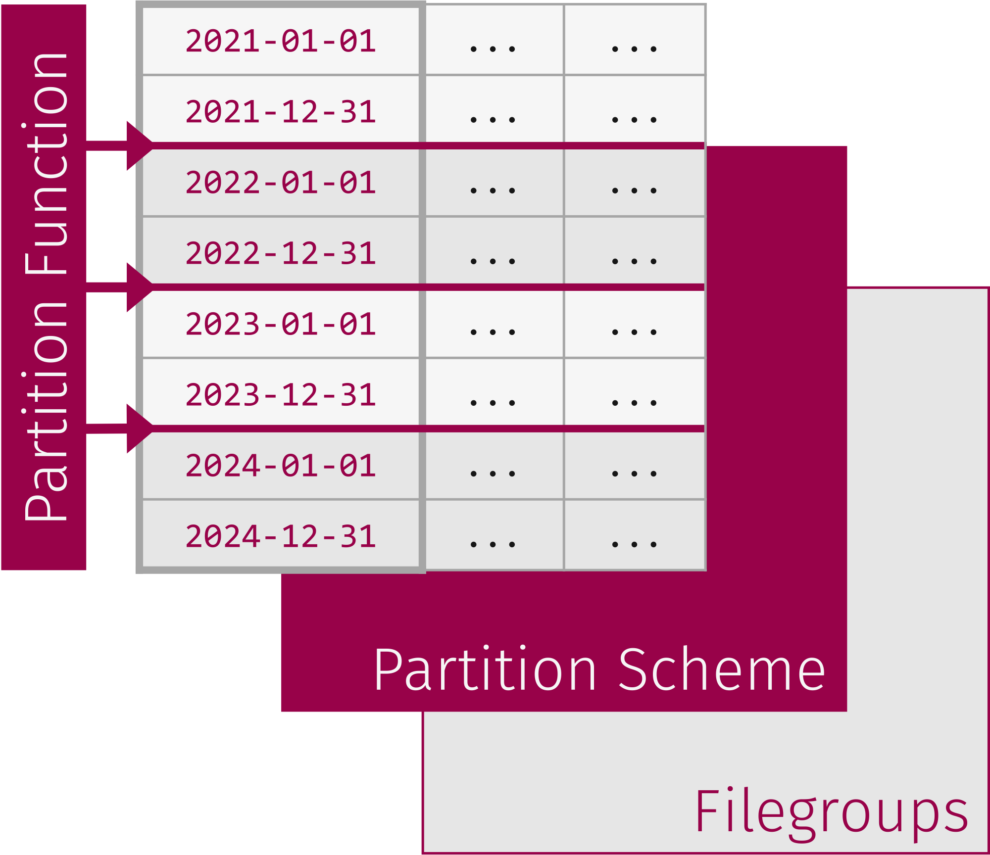

Real world usage:

*-- STEP 1: Create a filegroup for each sales year*

ALTER DATABASE Partition Demo ADD FILEGROUP [FGArchive]

GO

ALTER DATABASE Partition Demo ADD FILEGROUP [FG2018]

GO

*-- STEP 2: Create a file per file group*

ALTER DATABASE Partition Demo ADD FILE

(NAME = N'Sales_Archive',

FILENAME = N'C:\AW_Data\Sales_Archive.ndf' SIZE = 2048 KB) TO FILEGROUP [FGArchive]

GO

ALTER DATABASE Partition Demo ADD FILE

(NAME = N'Sales_Archive',

FILENAME = N'C:\AW_Data\Sales_2018.ndf' SIZE = 2048 KB) TO FILEGROUP [FG2018]

GO

*-- STEP 3: Create the Partition Function*

CREATE PARTITION FUNCTION pfOrderDateKey (INT)

AS RANGE LEFT FOR VALUES

(20171231, 20181231);

*-- STEP 4: Create the Partition Scheme*

CREATE PARTITION SCHEME psSales

AS PARTITION pfOrderDateKey

TO ([FGArchive], [FG2018]);

*-- STEP 5: Create the Partitioned Table (Heap) on the Partition Scheme with OrderDateKey as the Partition Column*

CREATE TABLE Sales (

SalesDate DATE,

Quantity INT,

OrderDateKey INT

) ON psSales(OrderDateKey);

Lesson 3

Cosmos DB

Lesson 4

Azure Stream Analytics

|  |  |  |  |  |  |
| --- | --- | --- | --- | --- | --- |
| **Tool** | | **Ingest** | **Store** | **Prep & Train**  **(analyse)** | **Model & Serve** |
|  | **Azure Stream Analytics** | ✓ |  | ✓x` |  |

Event Processing

Event

Producer

Event

Processor

Event

Consumer

Event producer Generates data continuously

Event Processor An engine to consume event data streams and derive insights

Event Consumer Application that consumes the data and takes specific action based on the insights

How does it work?

<https://www.youtube.com/watch?v=NbGmyjgY0pU>

1. Define Source

. Input Type & Properties

. Input Alias

2. Define Output

. Output Type & Properties

. Output Alias

3. Define Job SQL Query

. Fetch from source

. Select & transform data

. Insert into output

Example:

Data is grouped every 2 seconds, and the aggregate function returns the max of each group

**Stream Analytics windowing functions [T.H.S.S.S]**

<https://docs.microsoft.com/en-us/azure/stream-analytics/stream-analytics-window-functions>

Tumbling window functions are used to segment a data stream into distinct time segments and perform a function against them, such as the example below. The key differentiators of a Tumbling window are that they repeat, do not overlap, and an event cannot belong to more than one tumbling window.

Hopping window functions hop forward in time by a fixed period. It may be easy to think of them as Tumbling windows that can overlap and be emitted more often than the window size. Events can belong to more than one Hopping window result set. To make a Hopping window the same as a Tumbling window, specify the hop size to be the same as the window size.

Sliding windows, unlike Tumbling or Hopping windows, output events only for points in time when the content of the window changes. In other words when an event enters or exits the window. So, every window has at least one event. Like Hopping windows, events can belong to more than one sliding window.

Session window functions group events that arrive at similar times, filtering out periods of time where there is no data. It has three main parameters: timeout, maximum duration, and partitioning key (optional).

Snapshot windows groups events that have the same timestamp. Unlike other windowing types, which require a specific window function (such as [SessionWindow()](https://docs.microsoft.com/en-us/stream-analytics-query/session-window-azure-stream-analytics), you can apply a snapshot window by adding System.Timestamp() to the GROUP BY clause.

Lesson 5

Azure HD Insight

|  |  |  |  |  |  |
| --- | --- | --- | --- | --- | --- |
| **Tool** | | **Ingest** | **Store** | **Prep & Train** | **Model & Serve** |
|  | **Azure HDInsight**  **(Hadoop for azure)** |  |  | ✓ |  |
|  | **Azure Data Lake Analytics** |  |  | ✓ |  |
|  | **Azure Databricks**  **(python, Scala, Spark SQL, Spark R, Spark Structured Streaming)** |  |  | ✓ |  |

Lesson 6

Azure Synapse Analytics

<https://www.youtube.com/watch?v=WbDqeNsmoL4>

|  |  |  |  |  |  |
| --- | --- | --- | --- | --- | --- |
| **Tool** | | **Ingest** | **Store** | **Prep & Train** | **Model & Serve** |
|  | **Azure Data Factory** | ✓ |  |  |  |
|  | **Azure Synapse Analytics**  **(Azure SQL DW)** | ✓ |  |  | ✓ |

**Azure Synapse Analytics** [Azure]

Azure Synapse Analytics is generalized analytics service.

It uses a clustered architecture.

Azure Synapse is a:

- Data Warehouse solution

- Big Data solution

- Data Integration

… And a lot more!

You can use a variety of languages/frameworks with Azure Synapse Analytics

**Azure Synapse Workspace**

**Azure Synapse Studio**

Azure Synapse Studio offers everything in one place

Azure Synapse Analytics vs Synapse Dedicated SQL Pool (formerly SQL DW)

Dedicated SQL Pool

(formerly SQL DW)

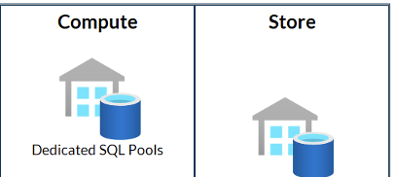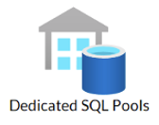

To load data into a normal DW, there are best practices.  
**M.D.I.P.I**

Azure Synapse Analytics

A table created in any pool will be immediately available to all the others

Lesson 6

Azure Synapse Analytics

**Distributions**

- A distribution is a basic unit of storage and processing.

**Sharding**

- A distributed table appears as a single table, but the rows are stored across 60 distributions.

- When a dedicated SQL Pool (DW) runs a query, the work is divided into 60 smaller queries that run in parallel i.e. it is divided into 60 **distributions**.

- When data is ingested into a dedicated SQL Pool (DW), the data is sharded into distributions to optimize the performance of the system.

The user has the option of which sharding pattern to use when defining the table

**Sharding Patterns**

A **round-robin distributed table**

**QUERY SPEED ↓**

**LOADING SPEED ↑**

Distributes rows evenly across all distributions.

The assignment of rows to distributions is random

A **hash distributed table**

**QUERY SPEED ↑**

*(on large fact tables)*

**LOADING SPEED ↓**

Distributes table rows across the Compute nodes by

using a deterministic hash function.

Assigns each row to one distribution.

CREATE TABLE [dbo].[FactInternetSales]

( [ProductKey] int NOT NULL

, [OrderDateKey] int NOT NULL

, [CustomerKey] int NOT NULL

, [PromotionKey] int NOT NULL

, [SalesOrderNumber] nvarchar(20) NOT NULL

, [OrderQuantity] smallint NOT NULL

, [UnitPrice] money NOT NULL

, [SalesAmount] money NOT NULL

)

WITH

( CLUSTERED COLUMNSTORE INDEX

, **DISTRIBUTION = HASH([ProductKey])**

);

<https://learn.microsoft.com/en-us/azure/synapse-analytics/sql-data-warehouse/sql-data-warehouse-tables-distribute>

Lesson 7

Moving data in Dedicated SQL Pool (formerly SQL DW)

1. Partitioning tables in dedicated SQL pool

*referred to as* ***switching out to archive data*** *from partitioned tables*

1. CREATE TABLE AS SELECT (CTAS) T-SQL statement in dedicated SQL pool
2. SELECT… INTO T-SQL statement

**CREATE TABLE AS SELECT**

<https://learn.microsoft.com/en-us/azure/synapse-analytics/sql-data-warehouse/sql-data-warehouse-develop-ctas>

The [CREATE TABLE AS SELECT](https://learn.microsoft.com/en-us/sql/t-sql/statements/create-table-as-select-azure-sql-data-warehouse?toc=/azure/synapse-analytics/sql-data-warehouse/toc.json&bc=/azure/synapse-analytics/sql-data-warehouse/breadcrumb/toc.json&view=azure-sqldw-latest&preserve-view=true) (CTAS) statement is one of the most important T-SQL features available.

CTAS is a parallel operation that creates a new table based on the output of a SELECT statement.

CTAS is the simplest and fastest way to create and insert data into a table with a single command.

Customizable version of **SELECT… INTO**

CREATE TABLE [dbo].[FactInternetSales_new]

WITH

(

**DISTRIBUTION = ROUND_ROBIN**

,CLUSTERED COLUMNSTORE INDEX

)

AS

SELECT *

FROM [dbo].[FactInternetSales];

Partitioning tables in dedicated SQL pool

1. Non-partitioned table to another non-partitioned table
2. Non-partitioned table to a partition in a partitioned table (*Load data by switching in*)
3. Partition in a partitioned table to a non-partitioned table (*Archive data by switching out*)
4. Partition in a partitioned table to a partition in another partitioned table

**1**

The first way to use the ALTER TABLE SWITCH statement is to switch all the data from a non-partitioned table to an empty non-partitioned table:

ALTER TABLE SourceTable SWITCH TO TargetTable;

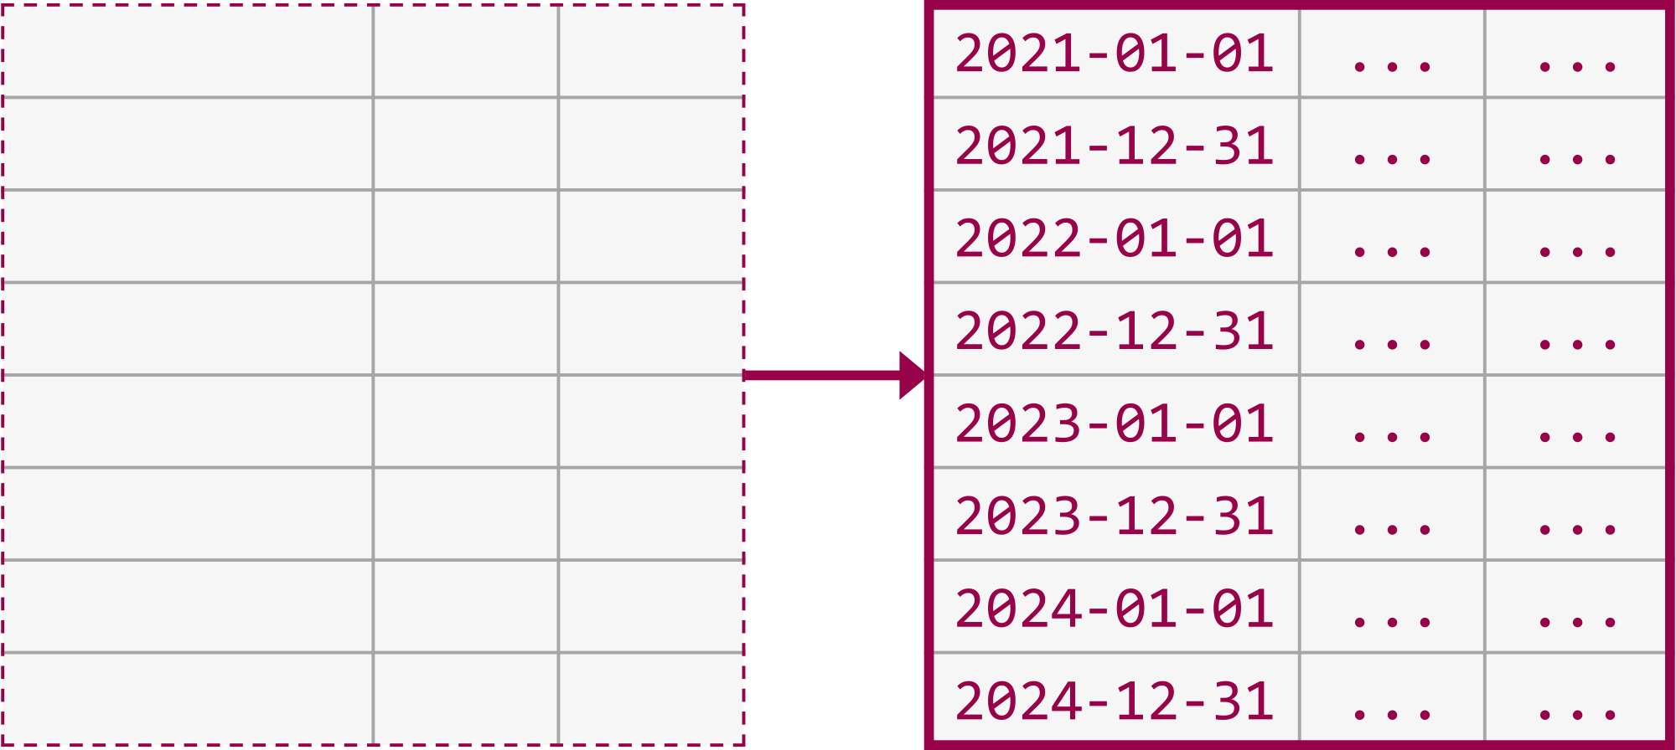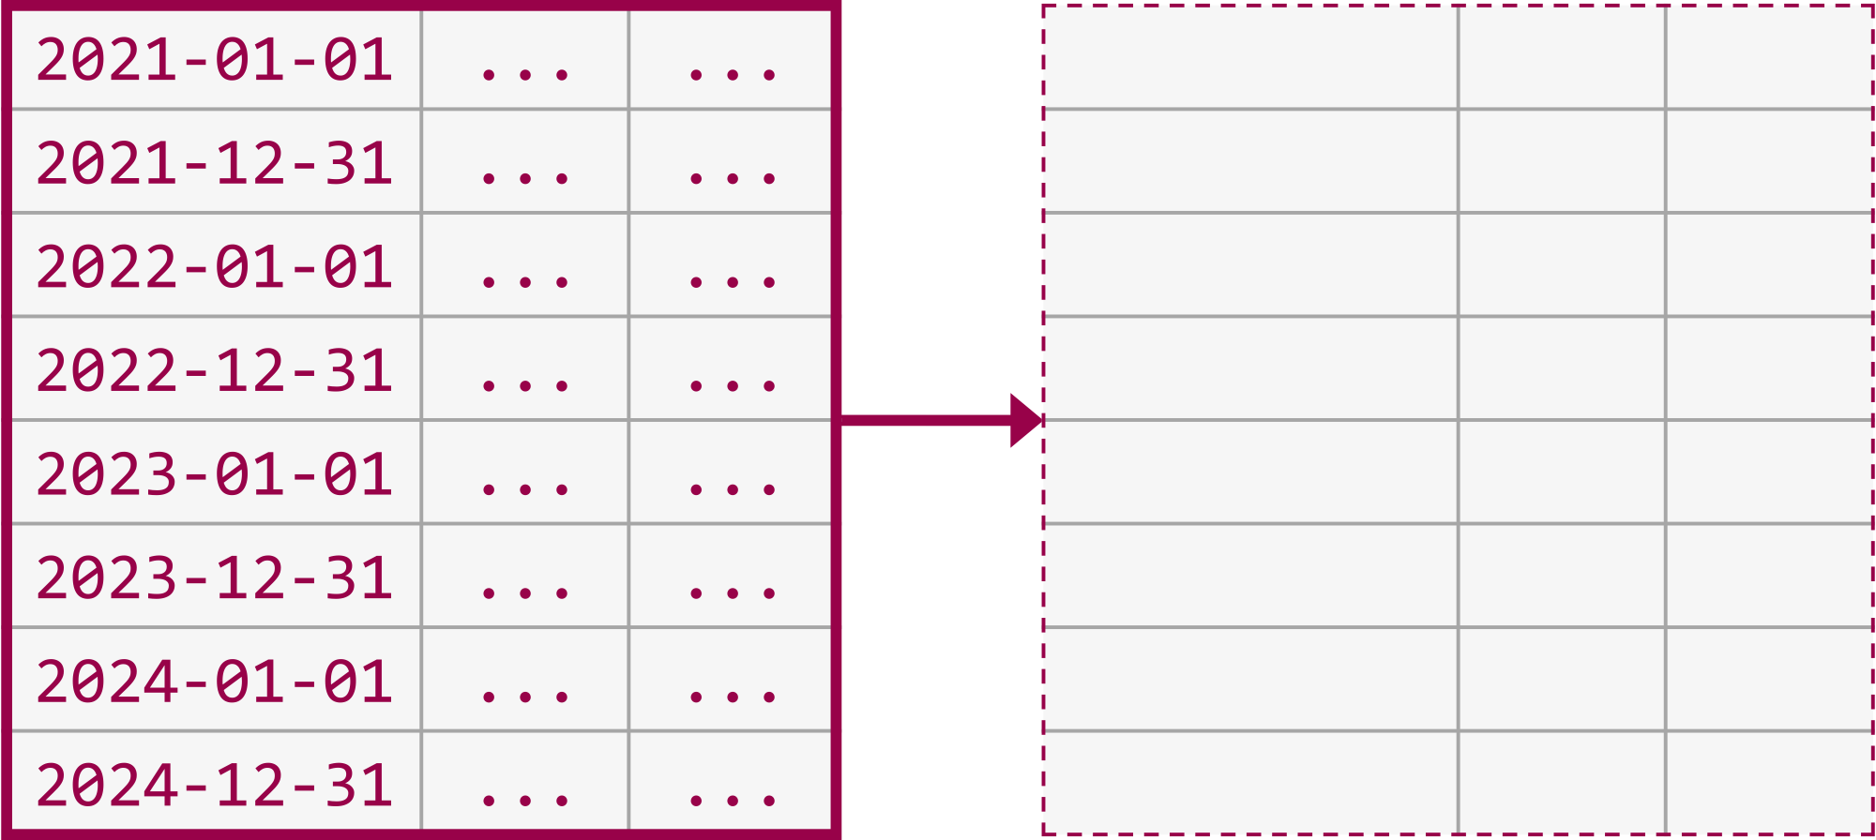

**BEFORE AFTER**

**2**

The second way to use the ALTER TABLE SWITCH statement is to switch all the data from a non-partitioned table to an empty specified partition in a partitioned table:

ALTER TABLE Source SWITCH TO Target PARTITION 1;

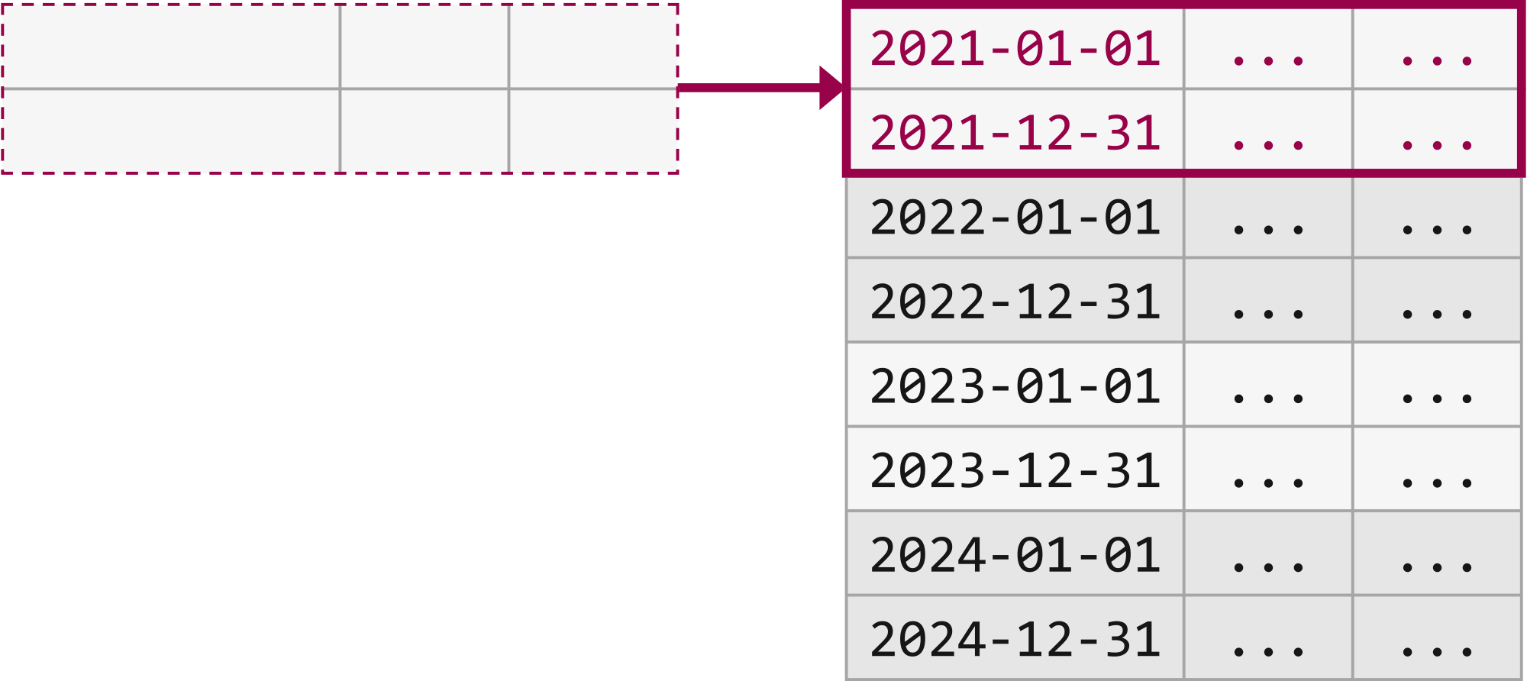

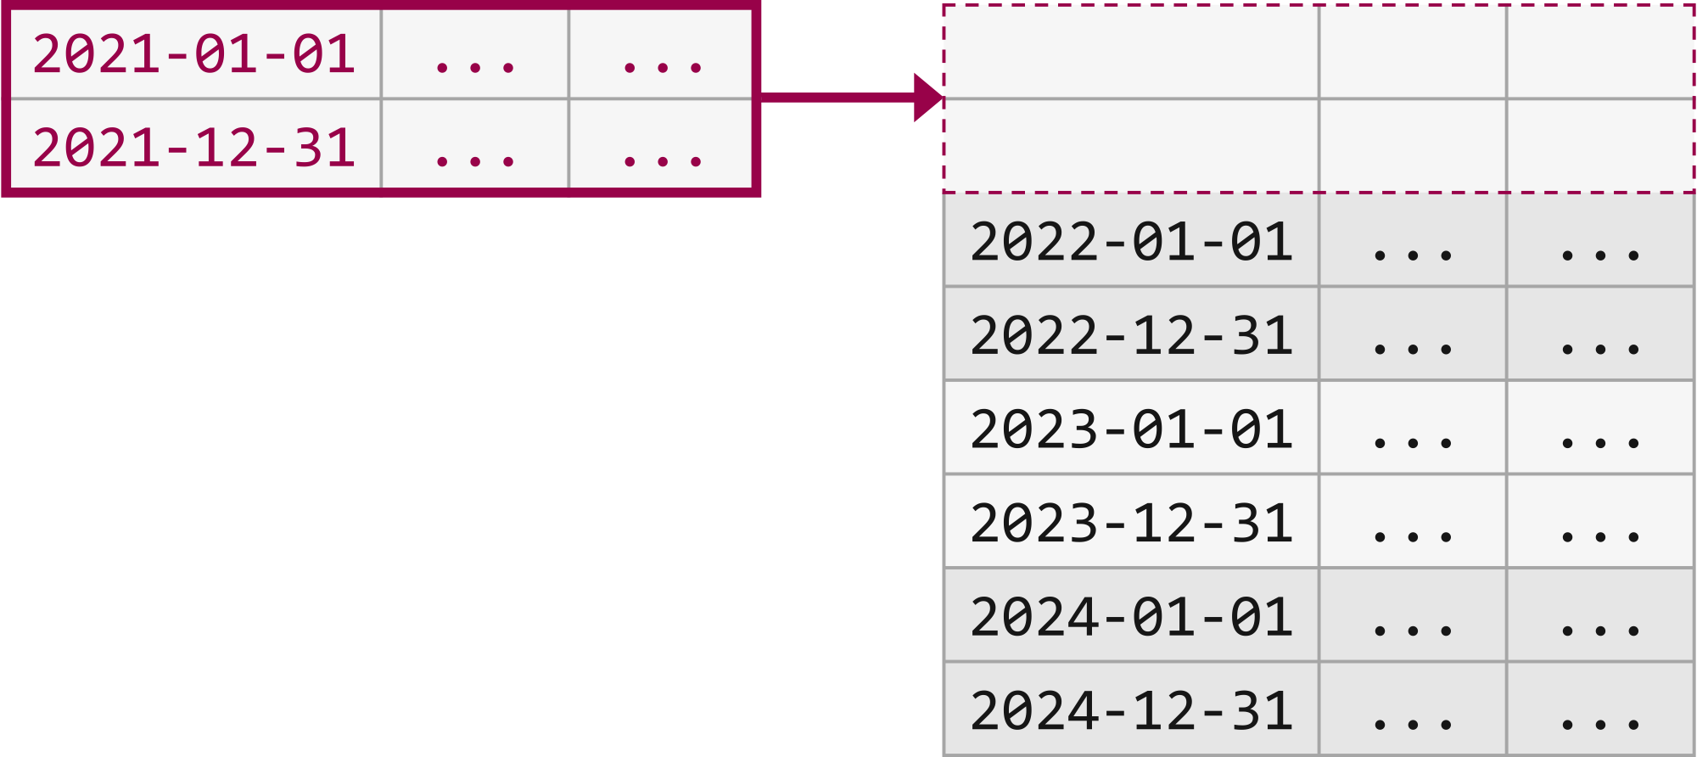

**BEFORE AFTER**

The third way to use the ALTER TABLE SWITCH statement is to switch all the data from a specified partition in a partitioned table to an empty non-partitioned table:

**3**

ALTER TABLE Source SWITCH PARTITION 1 TO Target;

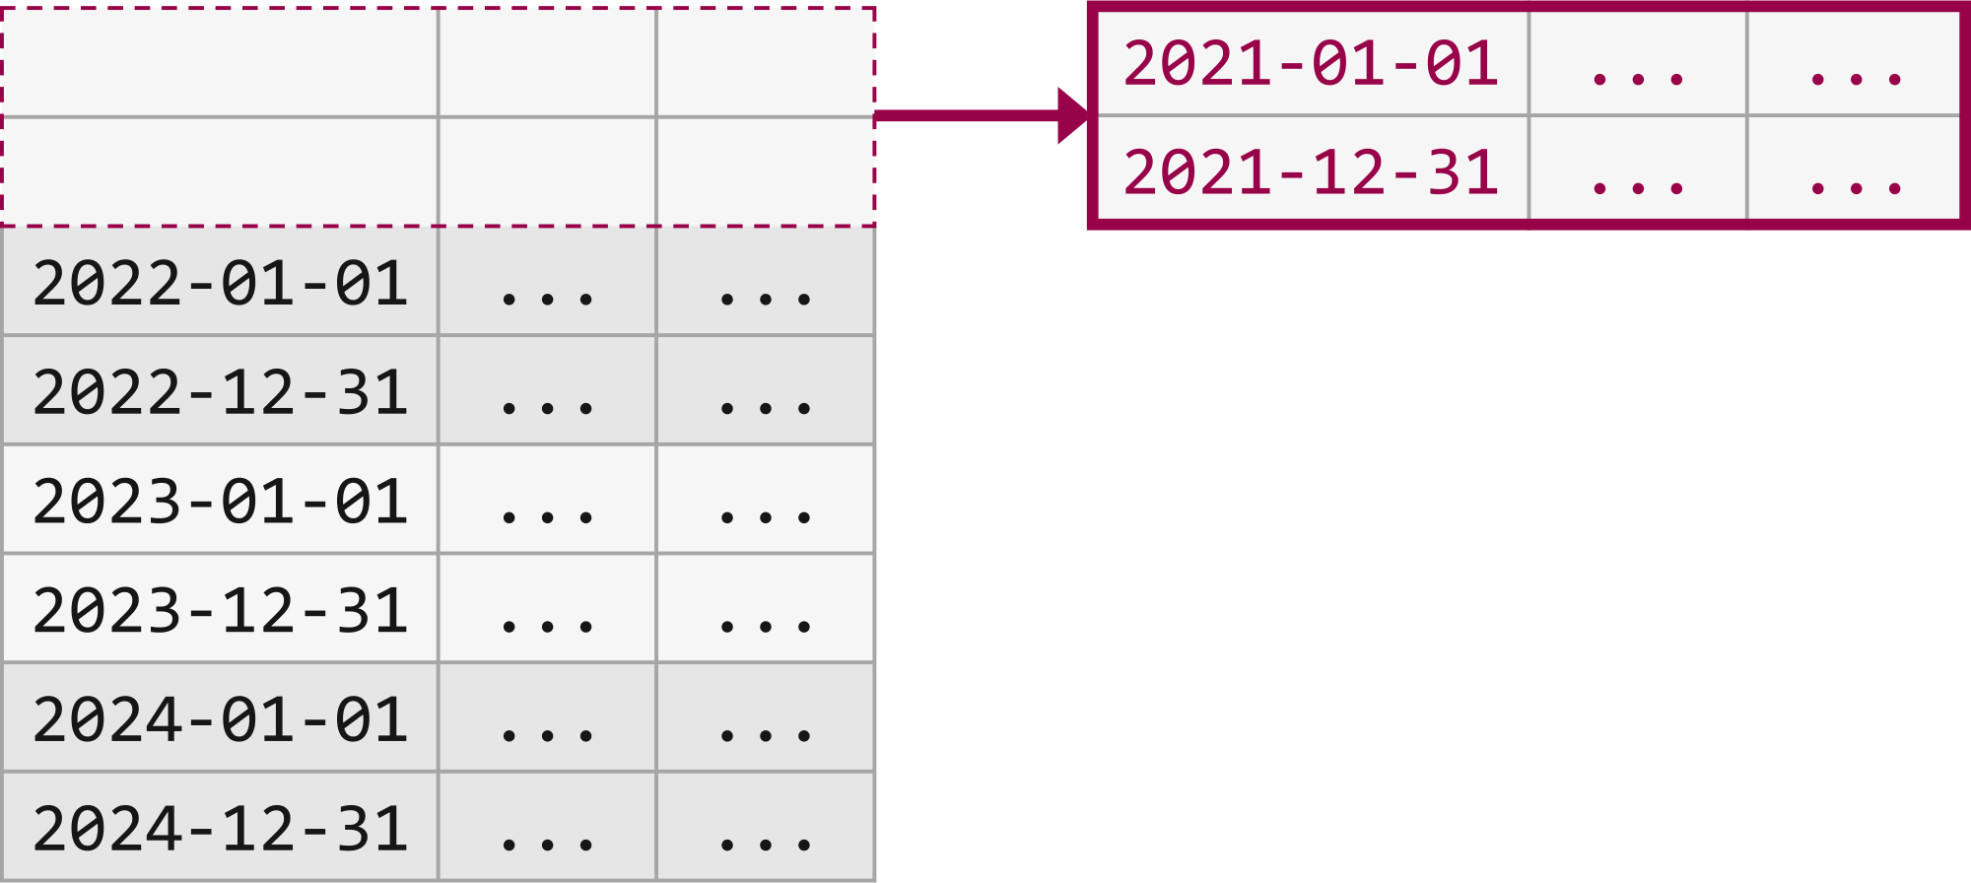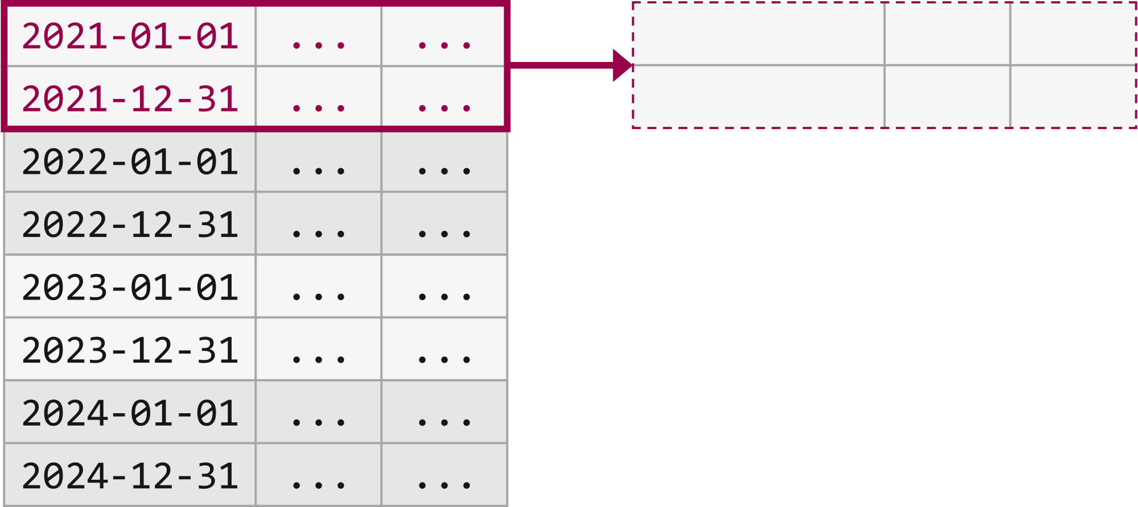

**BEFORE AFTER**

The fourth way to use the ALTER TABLE SWITCH statement is to switch all the data from a specified partition in a partitioned table to an empty specified partition in another partitioned table:

**4**

ALTER TABLE Source SWITCH PARTITION 1 TO Target PARTITION 1;

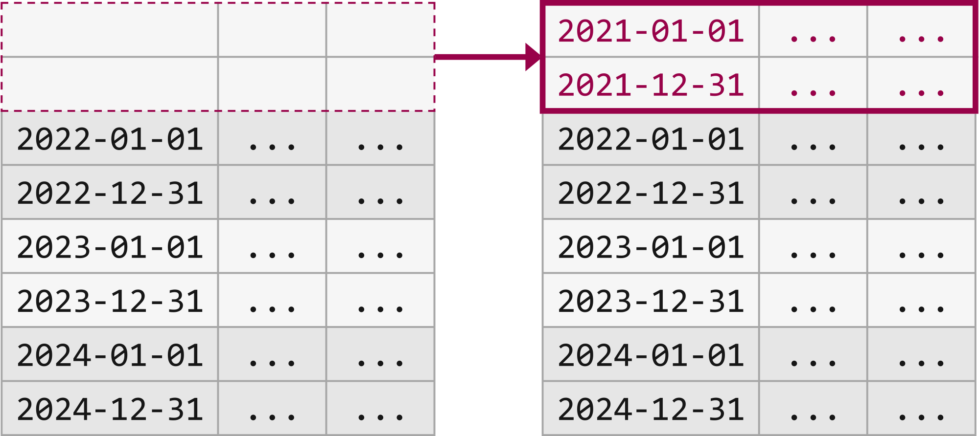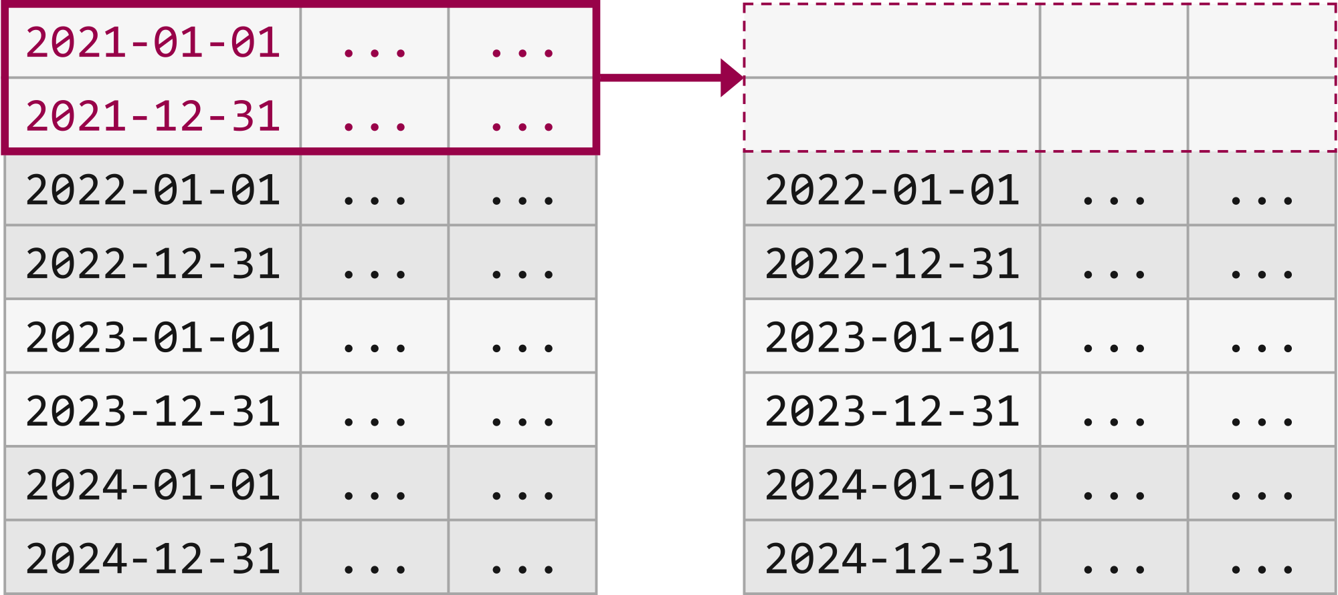

**BEFORE AFTER**

Lesson 8

**M**→**D**→**I**→**P**→**I**:

<https://learn.microsoft.com/en-us/azure/synapse-analytics/sql-data-warehouse/cheat-sheet>

Stuff to do when IMPLEMENTING a Data Warehouse

**5**

**3**

**4**

**2**

**1**

**Data migration**:

First, load your data into Azure Data Lake Storage or Azure Blob Storage.

Next, use the COPY statement (preview) to load your data into staging tables.

Use the following configuration:

|  |  |
| --- | --- |
| **Design** | **Recommendation** |
| Distribution | Round Robin |
| Indexing | Heap |
| Partition | None |
| Resource Class | largerc or xlargerc |

**Distributed or replicated tables**:

Start with Round Robin, but aspire to a hash distribution strategy to take advantage of a massively parallel architecture.

|  |  |  |
| --- | --- | --- |
| **Type** | **Great fit for…** | **Watch out if** |
| Replicated | * Small dimension tables in star schema (<2GB) | * Many write transactions (insert, upsert, delete, update)  * You change warehouse units (DWU) and provision frequently |
| Round Robin | * Temp/Staging Table  No obvious joining key | * Performance is slow due to data movement |
| Hash | * Fact Tables  * Large Dimension Tables | * The distribution key cannot be updated |

Stuff to do when IMPLEMENTING a Data Warehouse

**When to use each**

Fact

- Use hash-distribution with clustered columnstore index.

- Performance improves when two hash tables are joined on the same distribution column. Performance improves when two hash tables are joined on the same distribution column.

Dimension

- Use replicated for smaller tables.

- If tables are too large to store on each Compute node, use hash-distributed.

Staging

- Use round-robin for the staging table.

- The load with CTAS is fast.

- Once the data is in the staging table, use INSERT...SELECT to move the data to production tables.

**Index your tables**

Indexing is helpful for reading tables quickly. There is a unique set of technologies that you can use based on your needs:

|  |  |  |
| --- | --- | --- |
| **Type** | **Great fit for…** | **Watch out if** |
| Heap | Temp/Staging Table | * Any lookup scans the full table |
| Clustered Index  *nonclustered index to a column heavily used for filtering.* | Tables with up to 100 million rows  Large tables (more than 100 million rows) with only 1-2 columns heavily used | * Used on a replicated table * You have complex queries involving multiple join and Group By operations * You make updates on the indexed columns: it takes memory |
| Clustered columnstore index (CCI) (default) | Large tables (more than 100 million rows) | * Used on a replicated table  * You make massive update operations on your table |

**Partitioning**

You might partition your table when you have a large fact table (greater than 1 billion rows). In 99 percent of cases, the partition key should be based on date. Be careful to not overpartition, especially when you have a clustered columnstore index.

With staging tables that require ELT, you can benefit from partitioning. It facilitates data lifecycle management. Be careful not to overpartition your data, especially on a clustered columnstore index.

**Incremental load**

If you're going to incrementally load your data, first make sure that you allocate larger resource classes to loading your data.

This is particularly important when loading into tables with clustered columnstore indexes. See resource classes for further details.

For a large batch of updates in your historical data, consider using a [CTAS](https://learn.microsoft.com/en-us/azure/synapse-analytics/sql-data-warehouse/sql-data-warehouse-develop-ctas) to write the data you want to keep in a table rather than using INSERT, UPDATE, and DELETE.

CREATE TABLE [dbo].[FactInternetSales_new]

WITH

(

**DISTRIBUTION = ROUND_ROBIN**

,CLUSTERED COLUMNSTORE INDEX

)

AS

SELECT *

FROM [dbo].[FactInternetSales];

Customizable version of **SELECT… INTO**

Lesson 9

Polybase

*Azure SQL Database does not support PolyBase*

Feature of SQL Server and Azure Synapse Analytics

Enables you to run Transact-SQL queries that read data from external data sources (makes these sources appear like SQL tables).

Data Factory can directly invoke PolyBase on your behalf if your data is in a PolyBase-compatible data store.

**CREATE EXTERNAL TABLE**

<https://learn.microsoft.com/en-us/sql/t-sql/statements/create-external-table-transact-sql?view=sql-server-ver15&tabs=dedicated#location--folder_or_filepath>

creates an external table for PolyBase to access data stored in a Hadoop cluster or Azure blob storage PolyBase external table that references data stored in a Hadoop cluster or Azure blob storage.

*-- Create a new external table*

CREATE EXTERNAL TABLE { database_name.schema_name.table_name | schema_name.table_name | table_name }

( <column_definition> [ ,...n ] )

WITH (

**LOCATION = 'folder_or_filepath',**

DATA_SOURCE = external_data_source_name,

[ FILE_FORMAT = external_file_format_name ]

[ , <reject_options> [ ,...n ] ]

)

[;]

<reject_options> ::=

{

| REJECT_TYPE = value | percentage

| REJECT_VALUE = reject_value

| REJECT_SAMPLE_VALUE = reject_sample_value,

| REJECTED_ROW_LOCATION = '/REJECT_Directory'

}

<column_definition> ::=

column_name <data_type>

[ COLLATE collation_name ]

[ NULL | NOT NULL ]

**1**

**2**

\

**LOCATION = 'folder_or_filepath'**

**1**

Specifies the folder or the file path and file name for the actual data in Hadoop or Azure Blob Storage

If you specify LOCATION to be a folder, a PolyBase query that selects from the external table will retrieve files from the folder and all of its subfolders.

Just like Hadoop, PolyBase doesn't return hidden folders. It also doesn't return files for which the file name begins with an underline (_) or a period (.).

